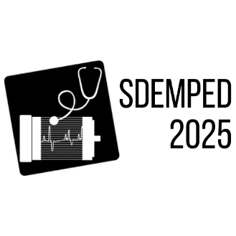

IEEE SDEMPED 2025

15th Edition of the IEEE International Symposium on Diagnostics for Electric Machines,

Power Electronics and Drives

24-27 August 2025 Dallas, Texas

**Tutorial on**:

***“Title of the proposed tutorial”***

Organizers

Title and full name, affiliation, country

email

&

Title and full name, affiliation, country

email

**Tutorial Scope and Learning Outcomes:**

Short description of the tutorial area and scope. The scope and outcomes should not exceed 1 page together with the conference info, title and organizers. This tutorial’s learning outcomes are as follows:

* Learning outcome 1
* Learning outcome 2
* etc…