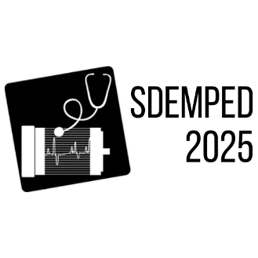

IEEE SDEMPED 2025

15th Edition of the IEEE International Symposium on Diagnostics for Electric Machines,

Power Electronics and Drives

24-27 August 2025 Dallas, Texas

**Special Session on**:

***“Title of the proposed special session”***

Organizers

Title and full name, affiliation, country

email

&

Title and full name, affiliation, country

email

**Tutorial Scope and Learning Outcomes:**

* Short description of the special session area and scope. The outline and topics should not exceed 1 page together with the conference info, title and organizers. Topics of interest include but are not limited as below:
* Topic 1
* Topic 2
* etc…